Warm Up

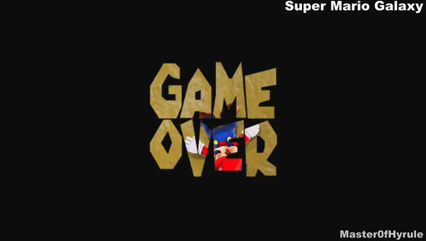

What do you think a game over state is and why is it important in a game?

|  |
| --- |